A

Report

On

World Philosophy Day 2024

Session :2024-25

Department of Philosophy

Rabindra Mahavidyalaya,

champadanga, Hooghly

Theme: World Philosophy Day

Venue: Rabindra Mahavidyalaya

Department of Philosophy

Room no 71

Date:21st November 2024

Organizer: Department of Philosophy

Objectives:

- To understand and respond to major contemporary challenges by creating the intellectual conditions for change
- To give a clear understanding of various subjects
- Realizing the Value of philosophy
- To make students aware of the importance of philosophy in the development of human thought.
- To create or engage interest in a new area
- to make students understand the learning concepts and prepare them for the real world. Therefore, teachers have been incorporating different strategies to enhance the efficacy of the lecture methods
- To develop analytical and independent thinking among students.
- Stimulating intercultural dialogue.
summary

On November 21st November, 2024, World Philosophy Day was celebrated in the Department of Philosophy. By celebrating World Philosophy Day each year, on the third Thursday of November, UNESCO underlines the enduring value of philosophy for the development of human thought, for each culture and for each individual.
On 21/11/2024 and22/11/2024, the Department of Philosophy of Rabindra Mahavidyalaya organized a two-day event to celebrate World Philosophy Day. The first day was a student’s Seminar and the second day was a Debate. The topic of the student’s seminar was SOHONSHILOTA (Tolerance). The first day of the event began at 11 am, First, Professor Soumitra Das head of the Department delivered the welcome address and explained the significance of World Philosophy Day. Then one by one the students presented their papers. A lively question and answer session were held after the presentation. The seminar provided an opportunity for students to think about this topic in a new way.4 teachers and 56 students were present in the event. Then event was concluded with a short cultural program.
The second day of the event began at 12pm, The next day’s program was a Debate among the students of the department. The topic discussed was the need for tolerance in the present era. The students were divided into two groups (for and against). both the sides presented their own opinions very beautifully.The teams participating in the competition express their thoughts through arguments and counterarguments. These sessions helped develop quick thinking, analytical skills, and the ability to express their opinions accurately in public among the students.
The two-day event was a great success. It helped to create a deep understanding among the students about the philosophical tradition and its importance in the modern context. The Head of the Department expressed the hope that such insightful discussions and competitions would be organized more in the future. At the end of the event, thanks were expressed to the participants, teachers and collaborators

Notice
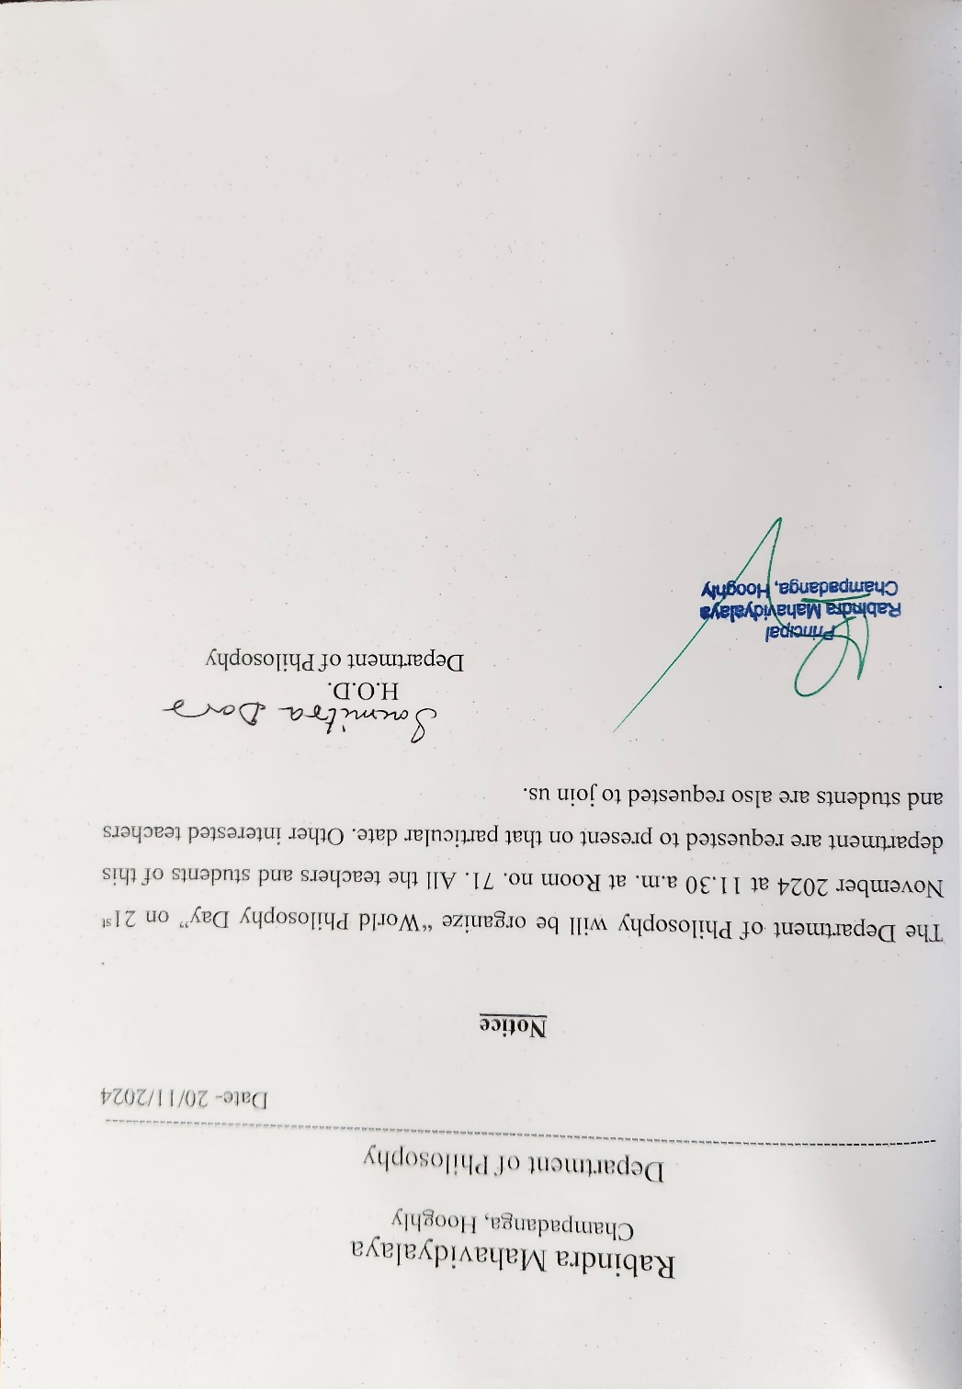

Our participants: 58
Male:11
Female:47
Attendance sheet
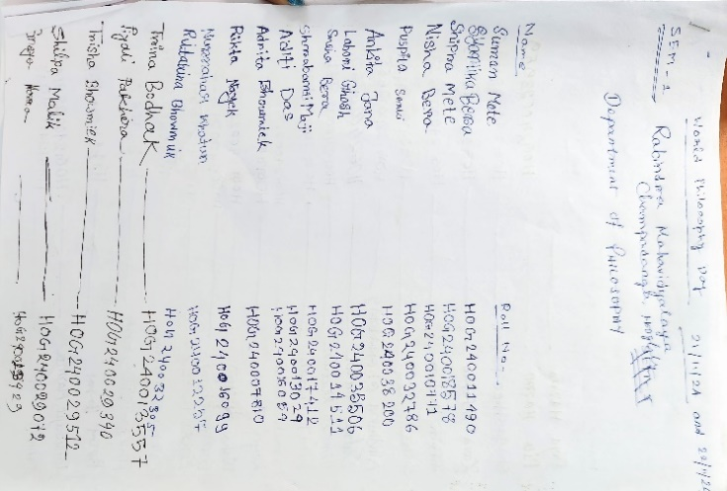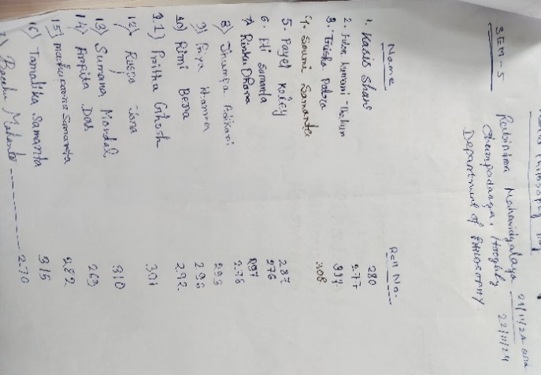
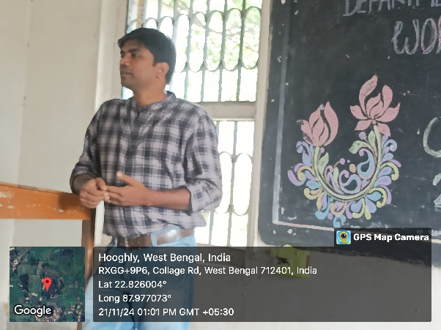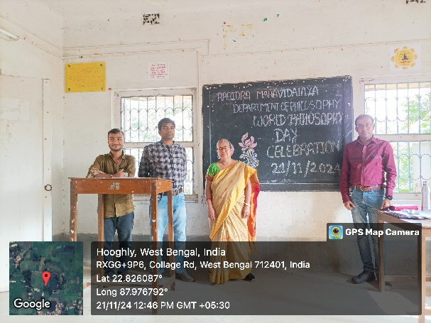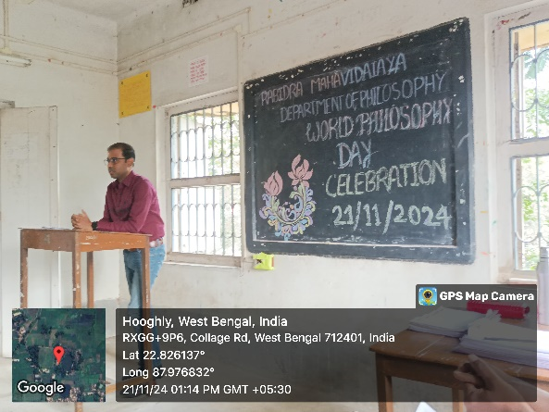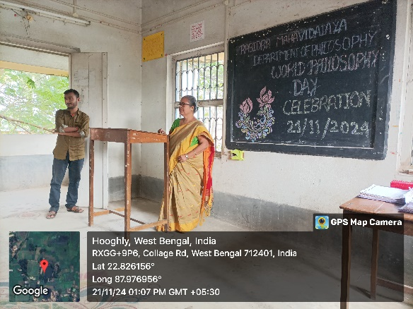
Inaugural session by the departmental professor
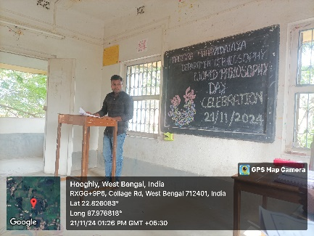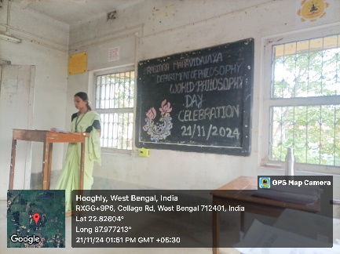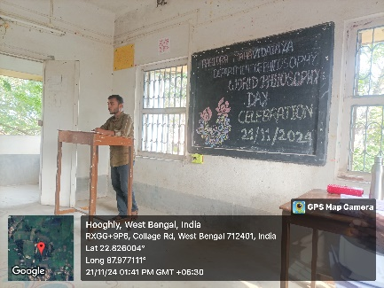
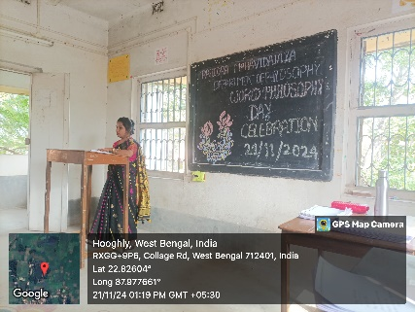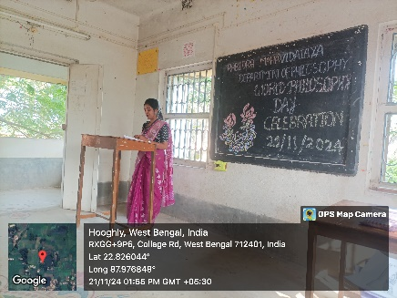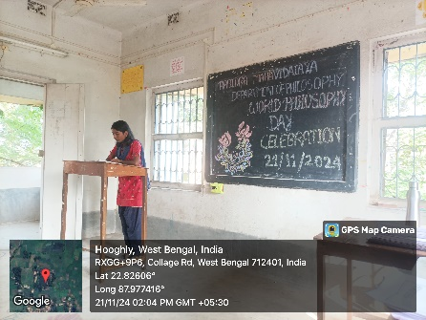
Paper presented by the students

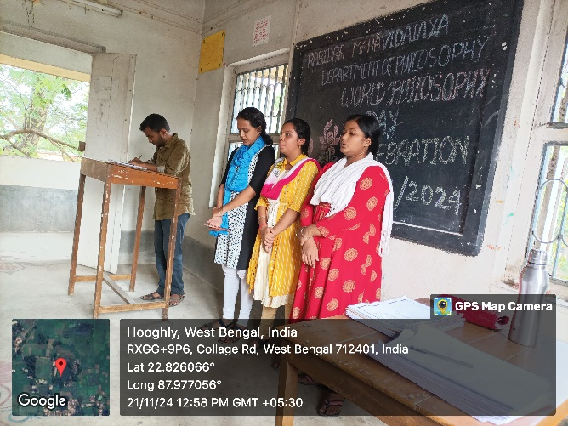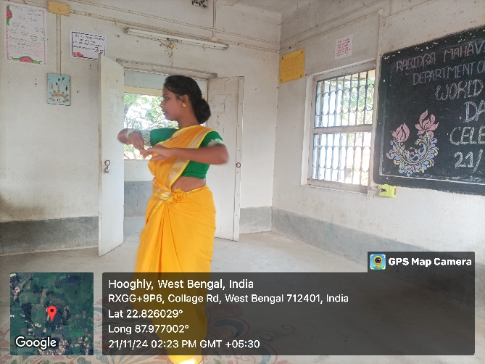
Cultural program
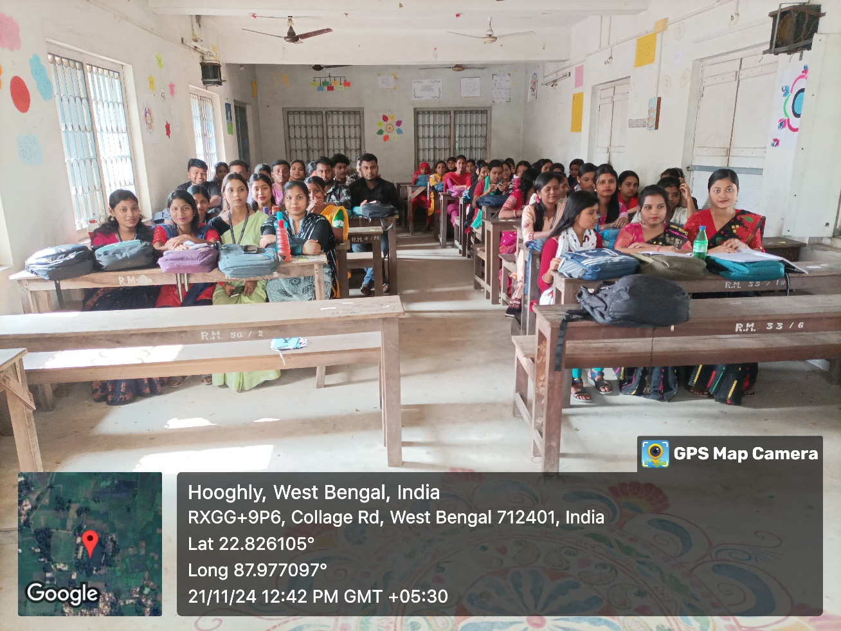

2nd day Debate
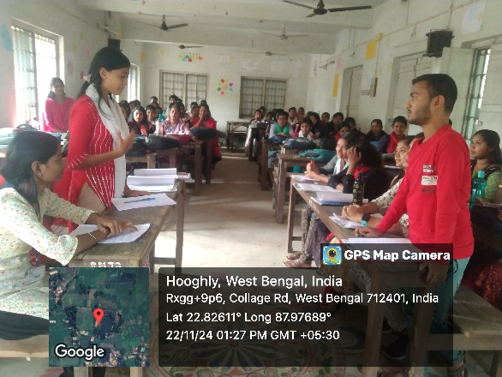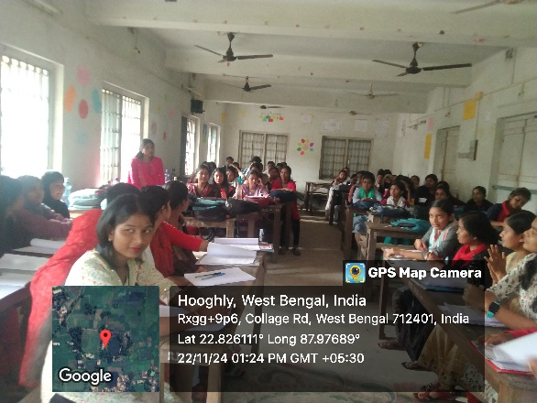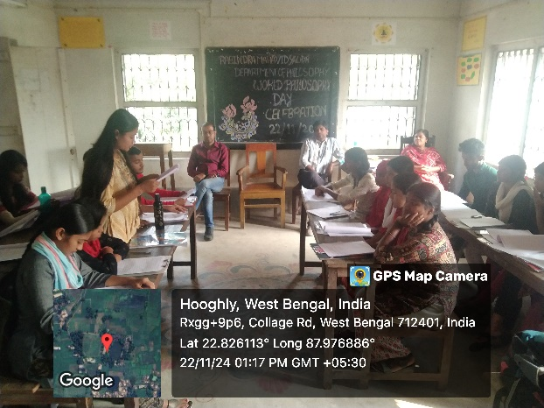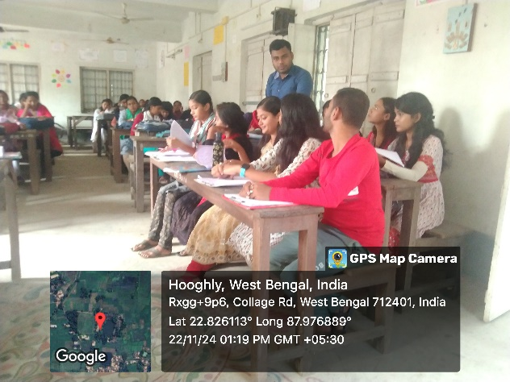
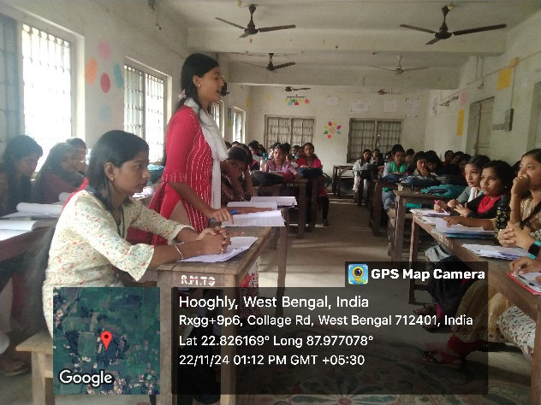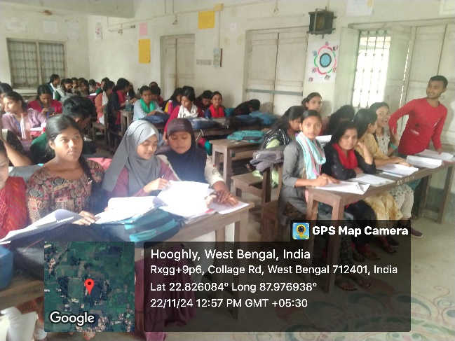
Debate session

Tentative programmed schedule
1st day
- Inaugural session: 11.00a.m. to 11.15 a.m.
- Inaugural speech:11.15a.m. to 1.00 noon
- Cultural programmed: 1.00 p.m. to 1.20 p.m.
2nd day
- Inaugural session: 12.00a.m. to 12.10 a.m.
- Debate started: 12.15p.m. to 3:00 p.m.

Feedback from students:

- 70% felt satisfactory
- 70 percent wished to occur the event more than once every year
- 100 percent students agreed this event helped to improve their logical performance
- Want more such philosophical topic, which is related to our daily life
- They want smart class room for this type of event

